** total data size 100M

range1(0.0, 10000.0); range2(1000000.0, 1001000.0); range3(100000000.0, 100010000.0);

1-1 原本的 bulkload中間再insert前後

Lookup time:

|  |  |  |  |  |
| --- | --- | --- | --- | --- |
|  | #1 | #2 | #3 | avg |
| 0.9 | 4930737880 | 5167702253 | 4379406009 | 4825948714 |
| 0.8 | 8645630734 | 9144024273 | 8546555889 | 8778736965 |
| 0.7 | 9331830991 | 12065621781 | 11818720885 | 11072057886 |
| 0.6 | 5266001335 | 7551247239 | 8256560371 | 7024602982 |
| 0.5 | 2955317699 | 3875164475 | 4105035205 | 3645172460 |
| 0.4 | 3510418904 | 3163557465 | 2831658367 | 3168544912 |
| 0.3 | 3198374470 | 1593300095 | 4944936758 | 3245537108 |
| 0.2 | 988940760 | 1166900063 | 1701568293 | 1285803039 |
| 0.1 | 660462194 | 518346985 | 655745132 | 611518103.7 |

Expand&resize times:

|  |  |  |  |  |
| --- | --- | --- | --- | --- |
|  | #1 | #2 | #3 | avg |
| 0.9 | 22.55 | 24 | 22.54 | 23.03 |
| 0.8 | 26.1 | 25.83 | 25.96 | 25.96333 |
| 0.7 | 29.95 | 30.87 | 30.42 | 30.41333 |
| 0.6 | 35.21 | 35.56 | 35.08 | 35.28333 |
| 0.5 | 40.4 | 41.81 | 40.78 | 40.99667 |
| 0.4 | 48.9 | 49.33 | 49.67 | 49.3 |
| 0.3 | 60.68 | 57.6 | 60.04 | 59.44 |
| 0.2 | 83.94 | 84.93 | 83.85 | 84.24 |
| 0.1 | 152.09 | 151.59 | 150.01 | 151.23 |

1. 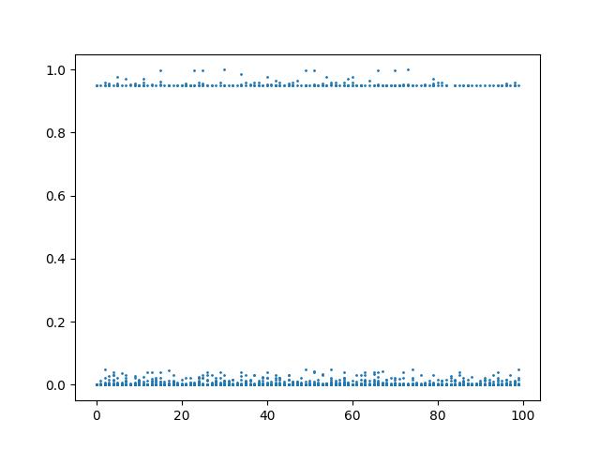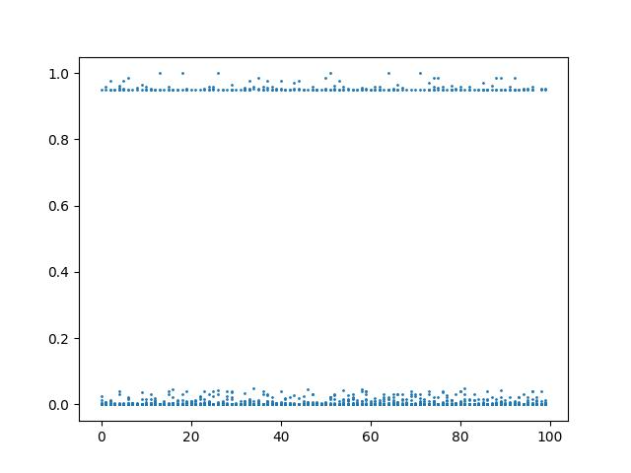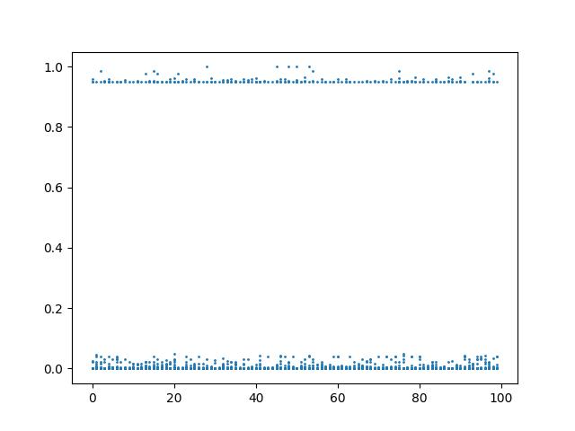range2改10000 bulkload all vs bulkload前 中 後 0.9-0.1 (計時)

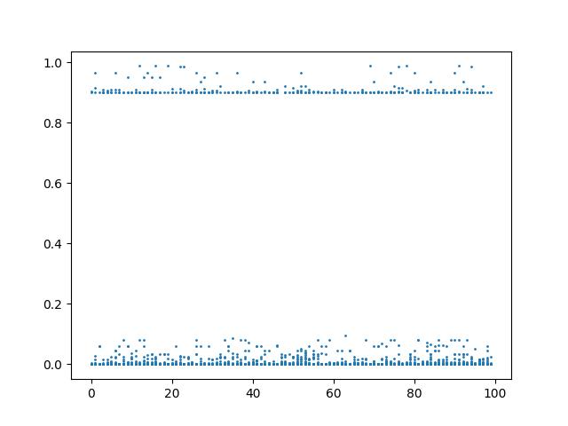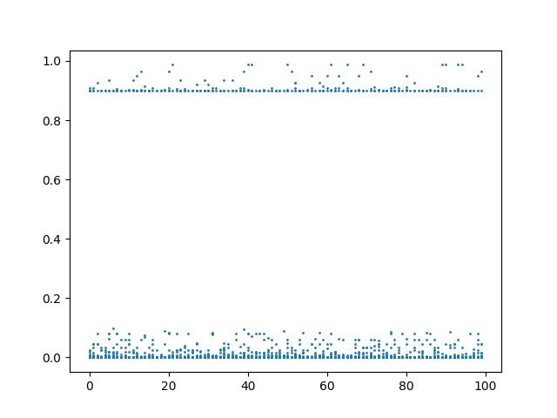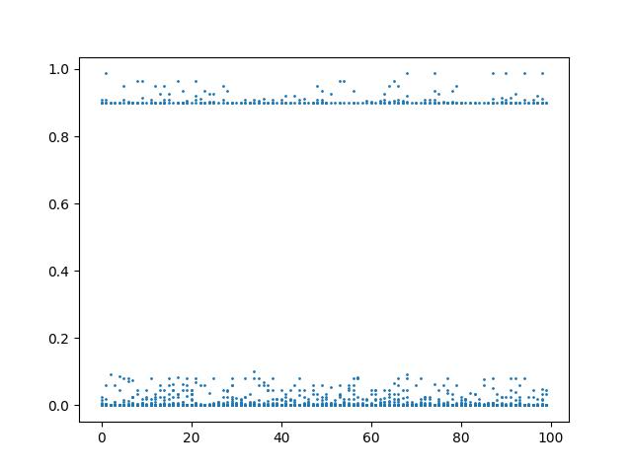0.8:

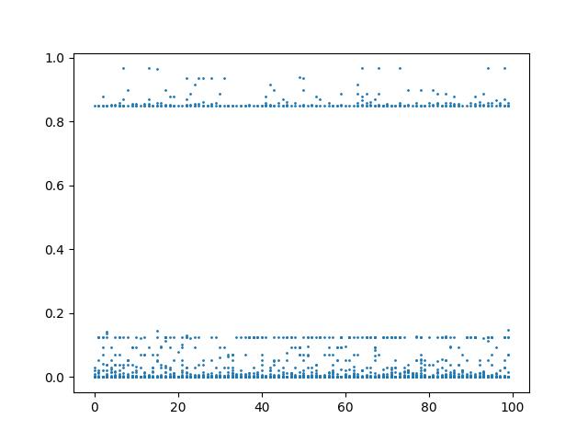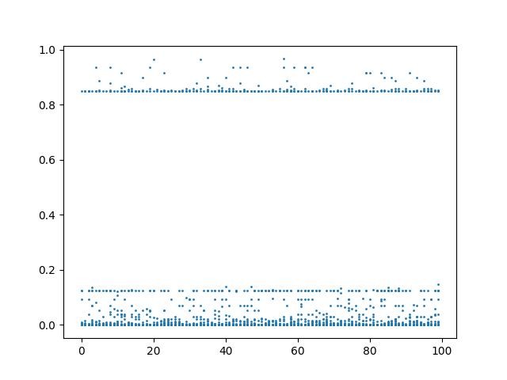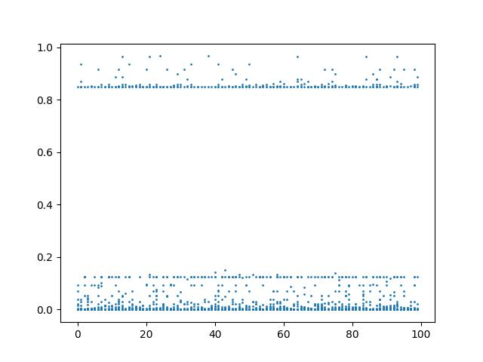0.7:

這邊開始出現一條明顯的線，表示這100筆測試數據中，插入15%左右必出現retrain?

會不會是look up time從0.7後就開始往下掉的原因?

但放大看可以發現前段發生retrain的點也不是完全隨機連續分布，是discrete的，後半就比較接近隨機(看random到多少 有多離群)

次數明顯前多後少

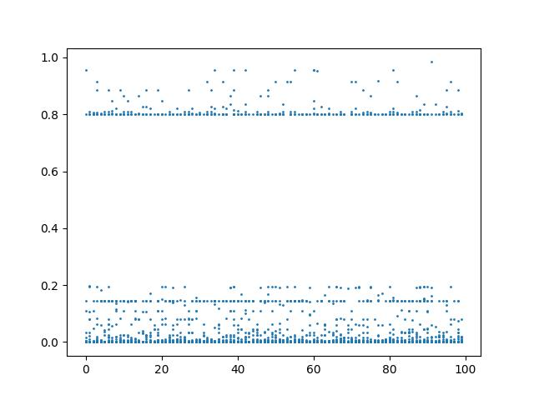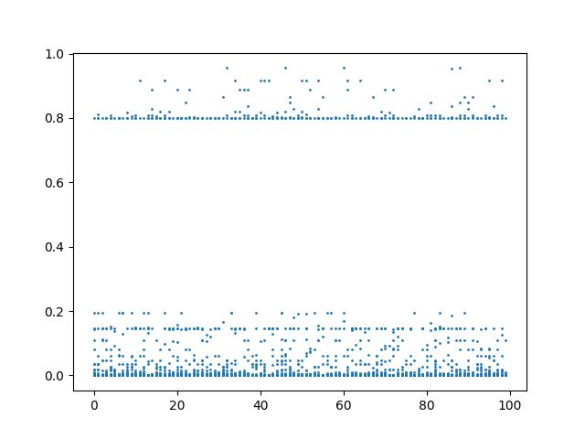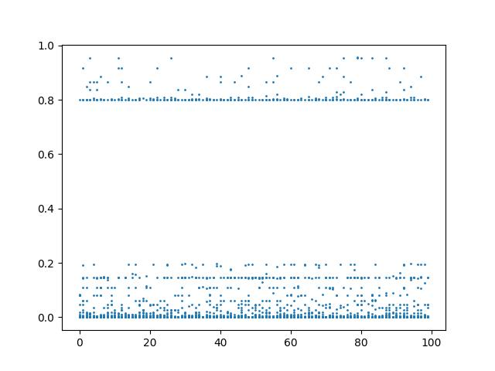0.6:

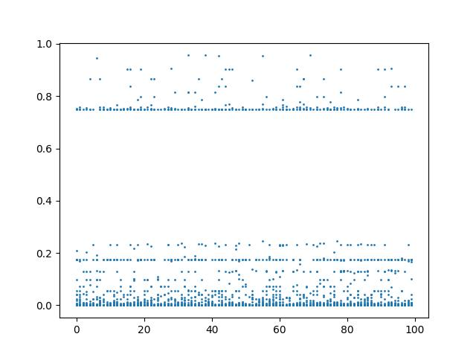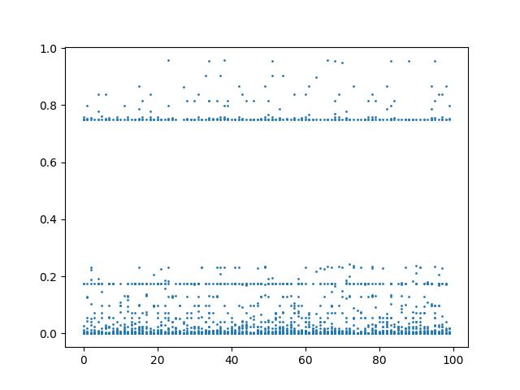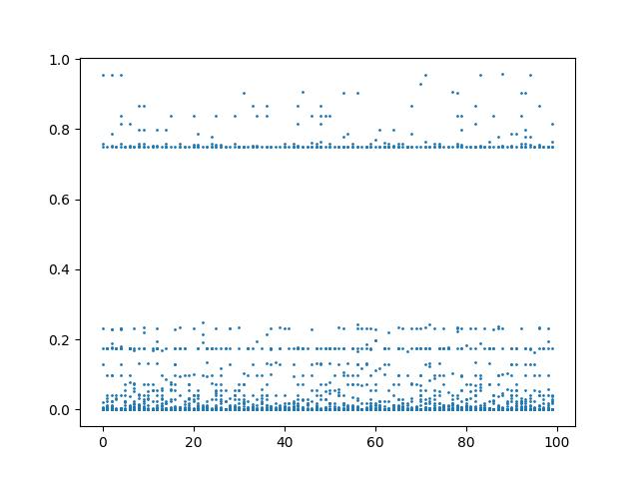0.5:

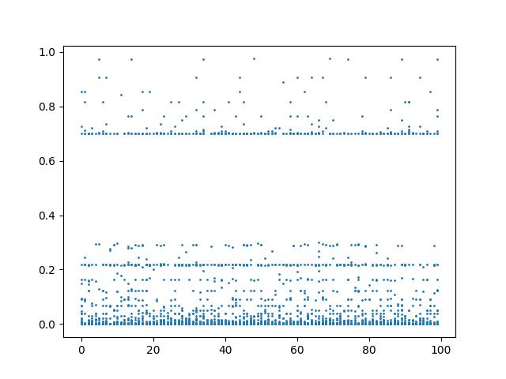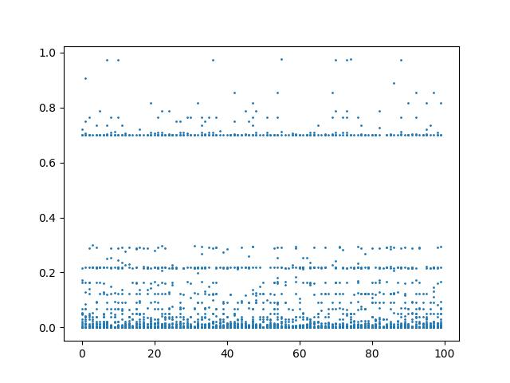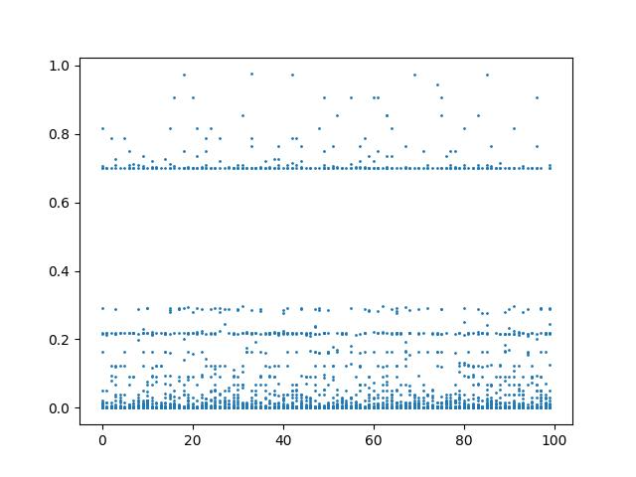0.4:

一起發生retrain的線往上移了(15%-2X%)..?

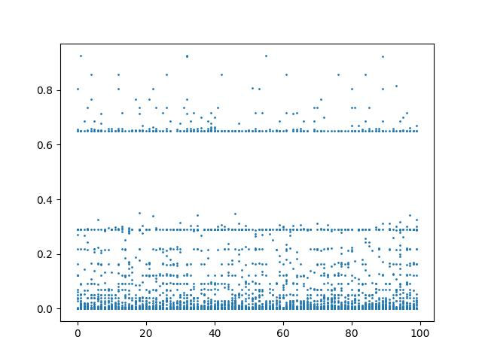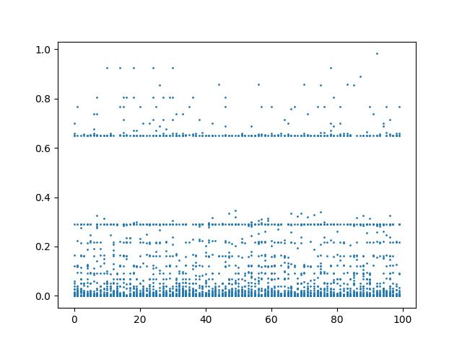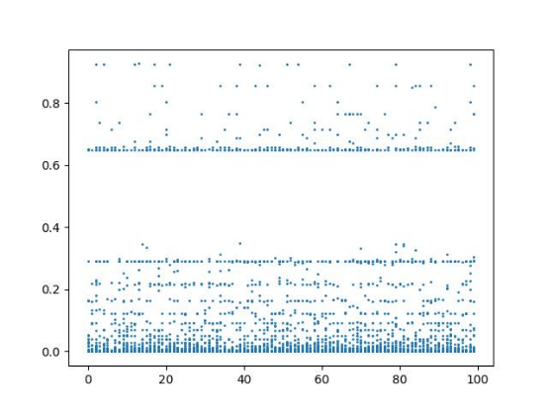0.3

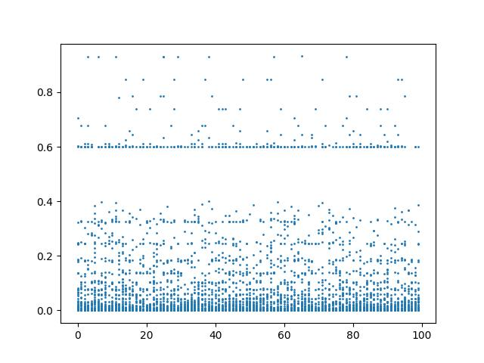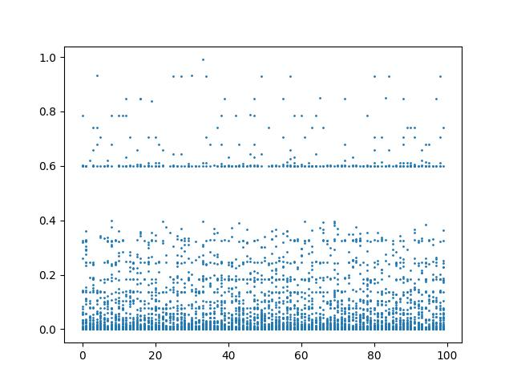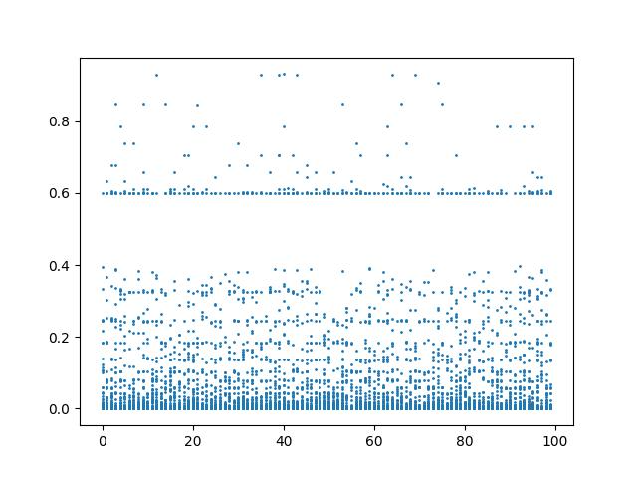0.2

預留空間的機制 insert的耗時(用以判斷expand/retrain/都沒有)

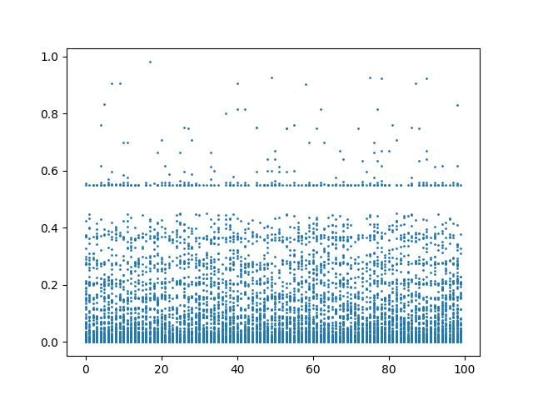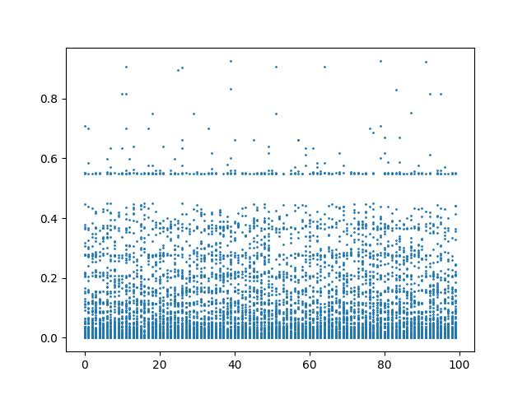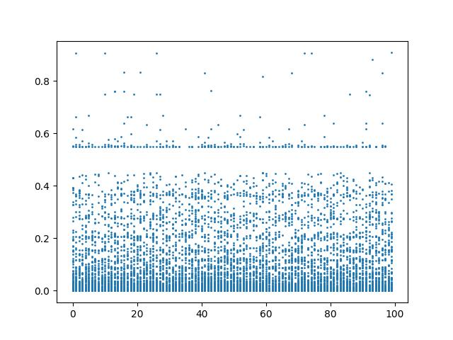0.1

1-2新的 bulkload中間跟前面 再insert後

Lookup time:

|  |  |  |  |  |
| --- | --- | --- | --- | --- |
|  | #1 | #2 | #3 | avg |
| 0.9 | 7201213980 | 7336259002 | 7655639260 | 7397704081 |
| 0.8 | 7353389944 | 7307050712 | 7798692609 | 7486377755 |
| 0.7 | 7261351264 | 7704304890 | 6687526032 | 7217727395 |
| 0.6 | 4784827326 | 5530061359 | 5881443737 | 5398777474 |
| 0.5 | 3660453641 | 3753445720 | 3859119474 | 3757672945 |
| 0.4 | 1448547930 | 2610461090 | 3168305320 | 2409104780 |
| 0.3 | 886525595 | 1824543081 | 1630235230 | 1447101302 |
| 0.2 | 984154079 | 833056743 | 1134224430 | 983811750.7 |
| 0.1 | 958173891 | 817952454 | 779316680 | 851814341.7 |

Expand&resize times:

|  |  |  |  |  |
| --- | --- | --- | --- | --- |
|  | #1 | #2 | #3 | avg |
| 0.9 | 2.35 | 2.38 | 2.24 | 2.323333 |
| 0.8 | 2.68 | 2.57 | 2.68 | 2.643333 |
| 0.7 | 2.96 | 2.85 | 2.83 | 2.88 |
| 0.6 | 2.68 | 3.35 | 2.94 | 2.99 |
| 0.5 | 3 | 3.04 | 3.13 | 3.056667 |
| 0.4 | 3.19 | 3.21 | 3 | 3.133333 |
| 0.3 | 10.88 | 10.86 | 11.18 | 10.97333 |
| 0.2 | 22.63 | 22.52 | 23.28 | 22.81 |
| 0.1 | 79.11 | 76.8 | 75.36 | 77.09 |

Look up time的peak不見了!

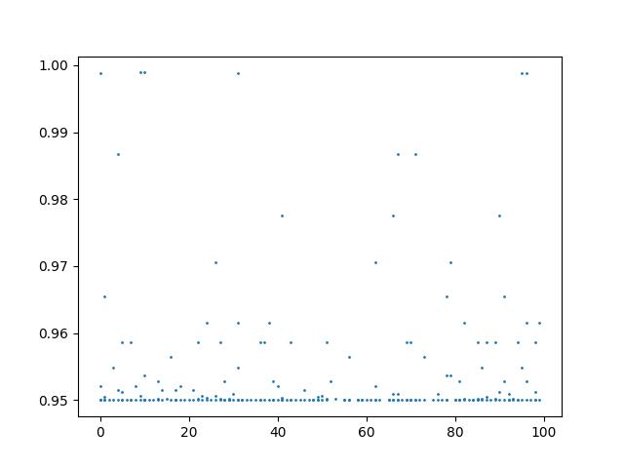0.9

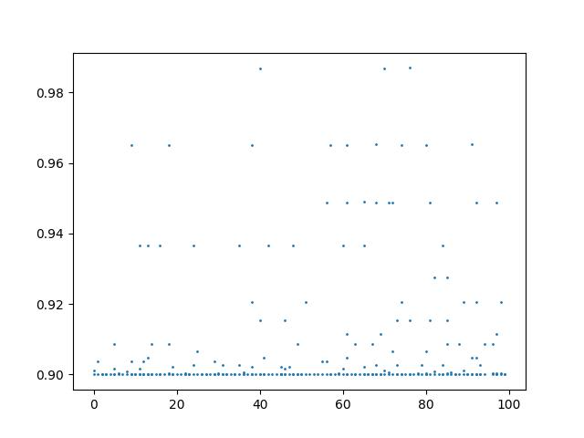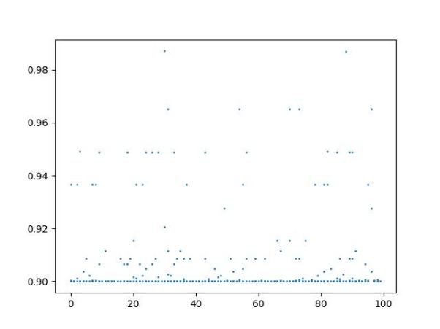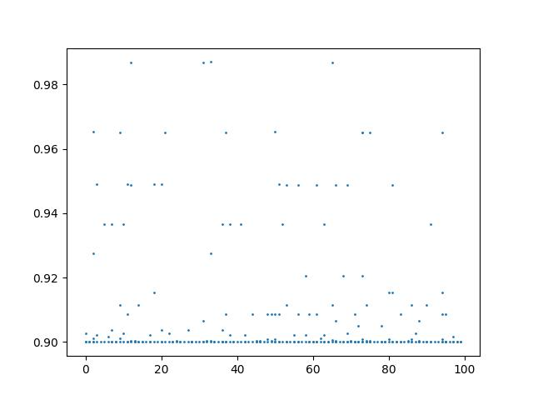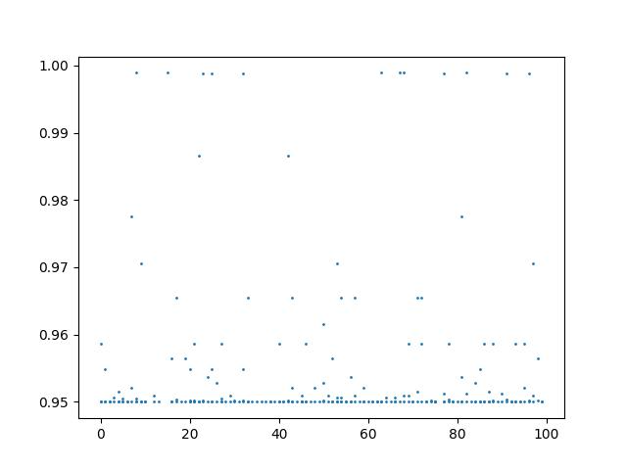 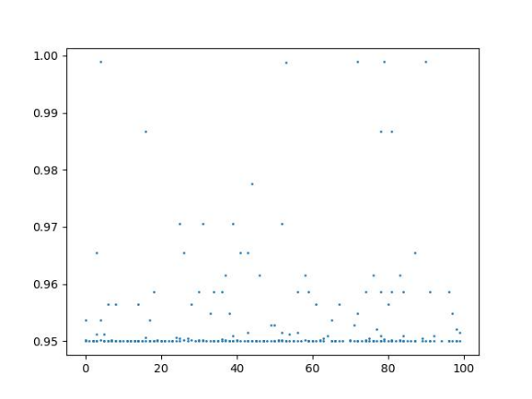0.8

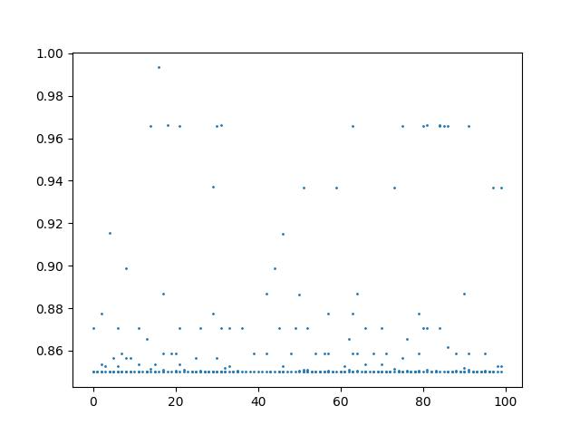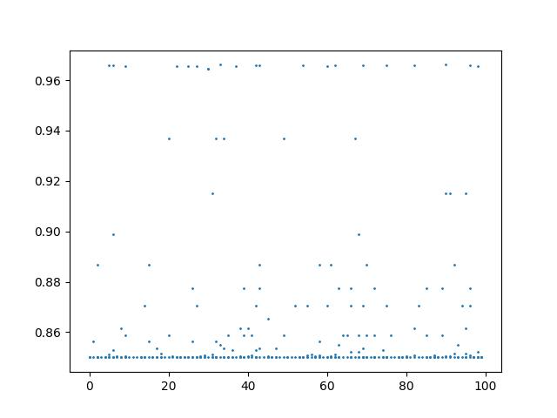 0.7

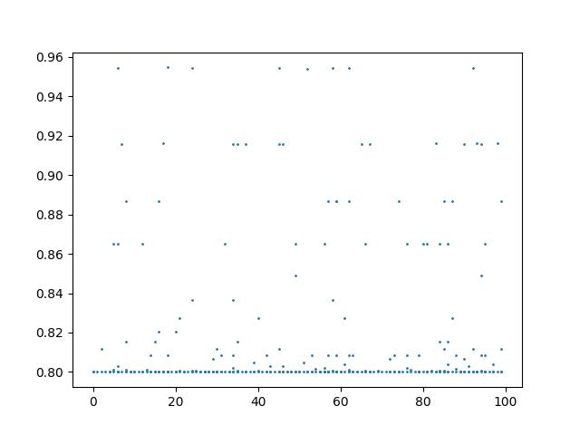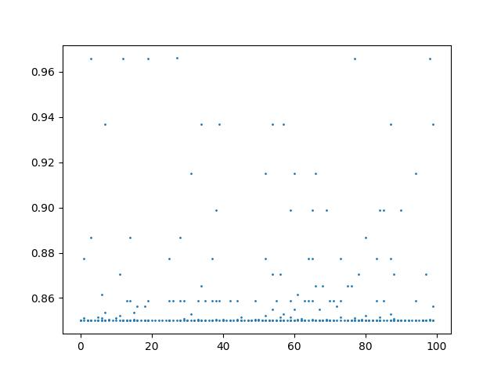 0.6

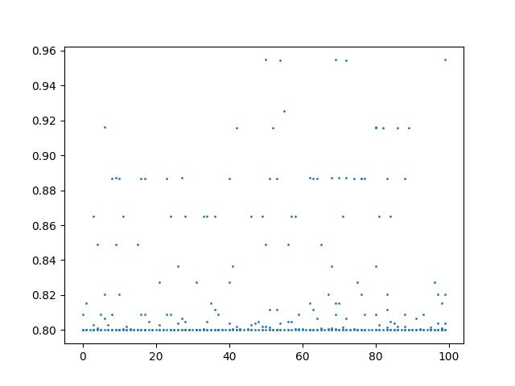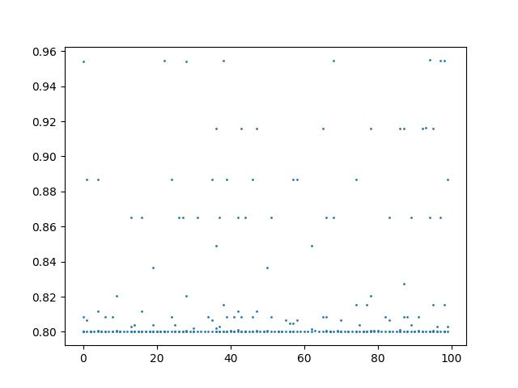

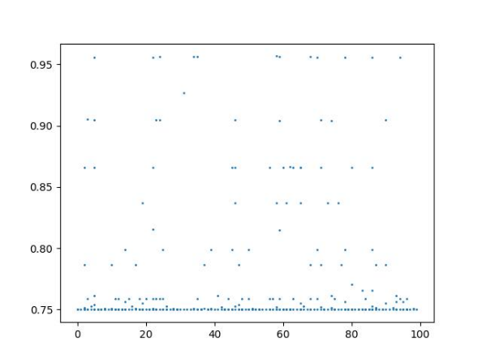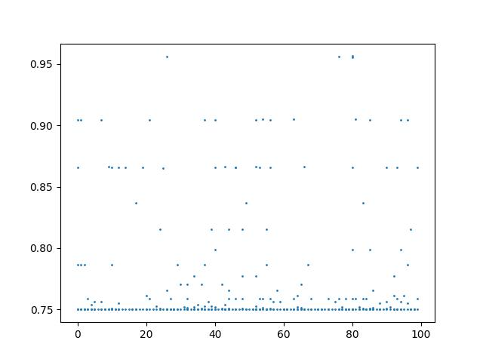0.5

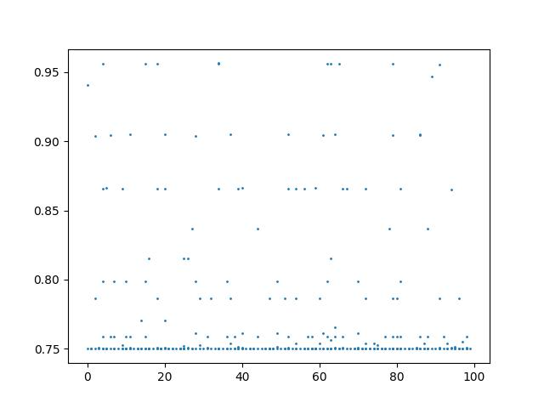

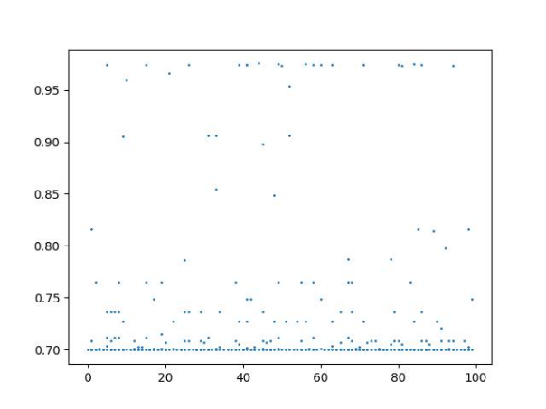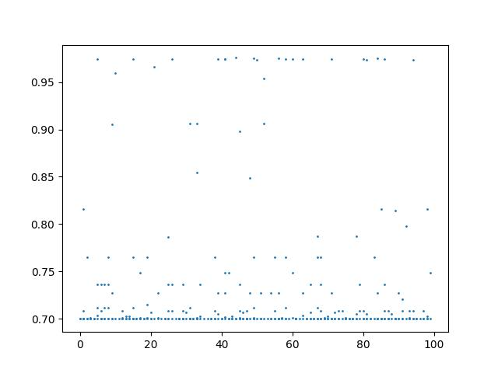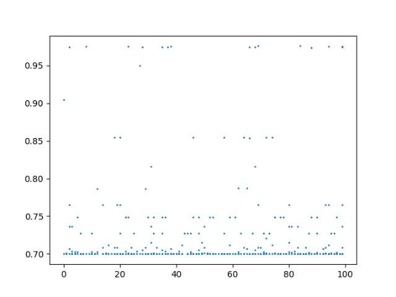0.4

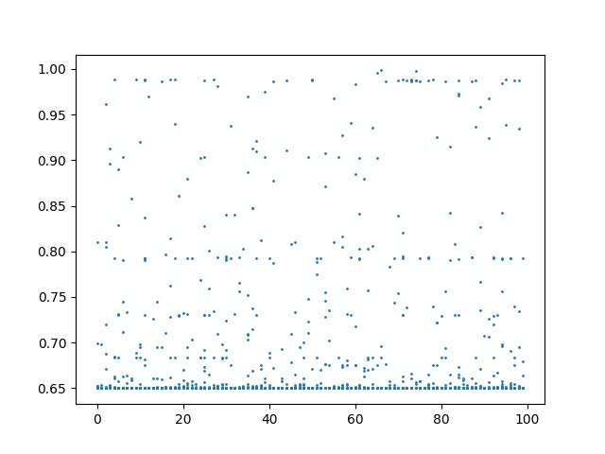0.3

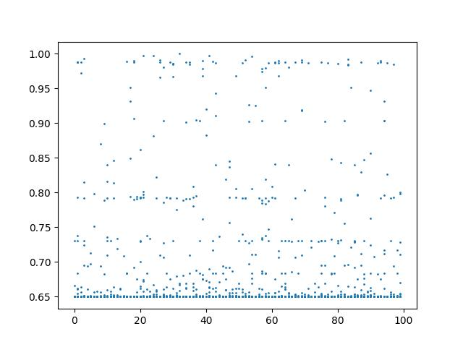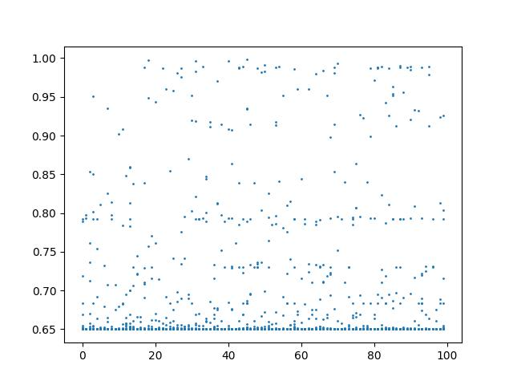

0.2

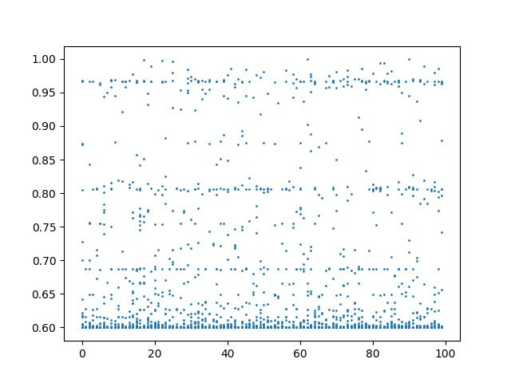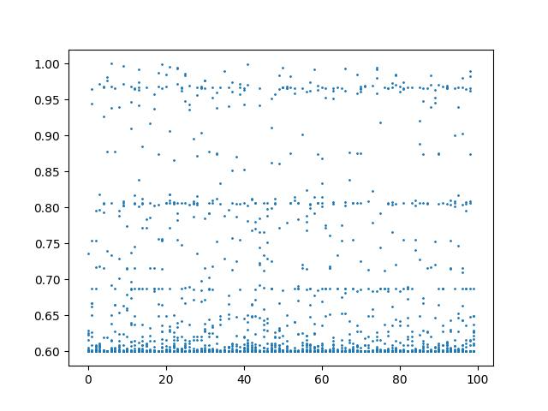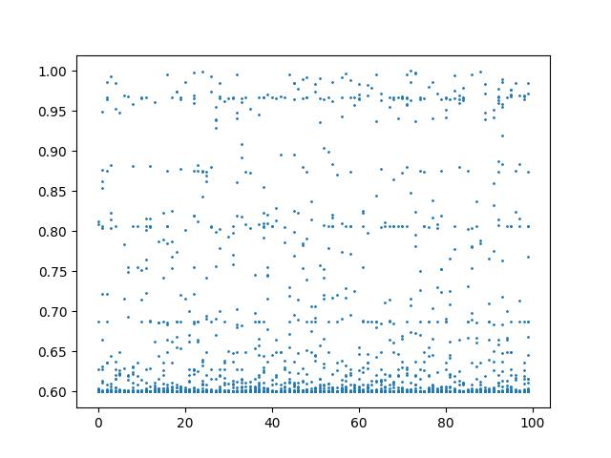

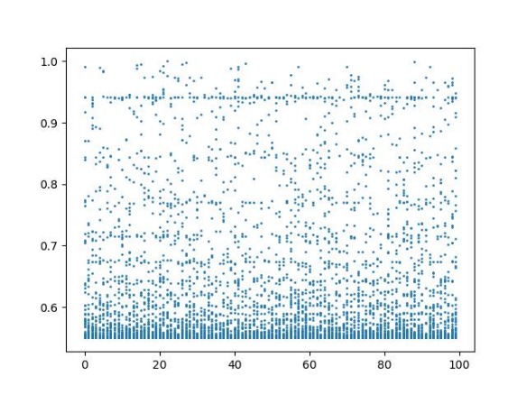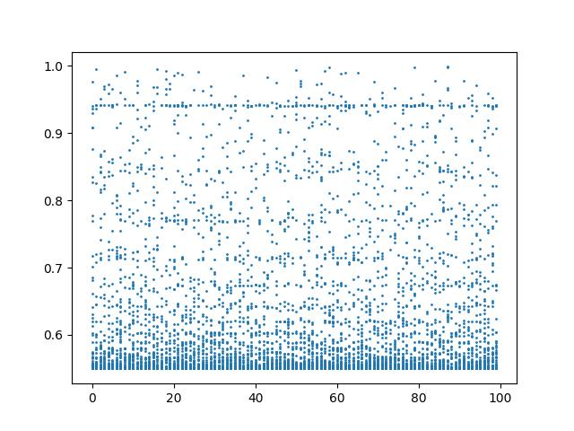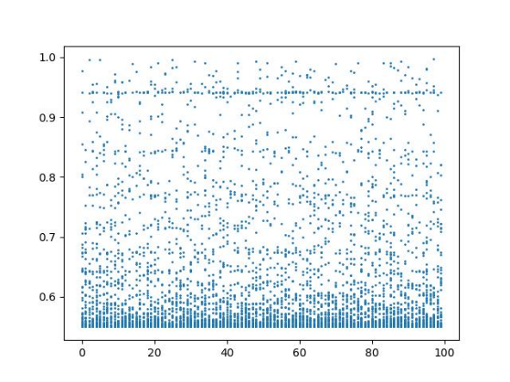0.1: